1.Client PC Setup

Connect Client PC and Baseband5216/6630 with LMT port

› Configure the Client PC’s IP address as follows;

- IP Address : 169.254.2.1

- Subnet mask : 255.255.0.0

- Default gateway : 169.254.2.2

› Stop the Symantec Management Client Service if you use

Ericsson PC

(Services -> Symantec Management Client

and Press stop) and set

“Out of Ericsson premises”

**Login Cygwin by using command:**

**moshell 169.254.2.2**

**Lt all**

**User:-rbs**

**PWD:-rbs**

* To Login

User name- rbs

P.W- rbs

* To check cell status

St cell

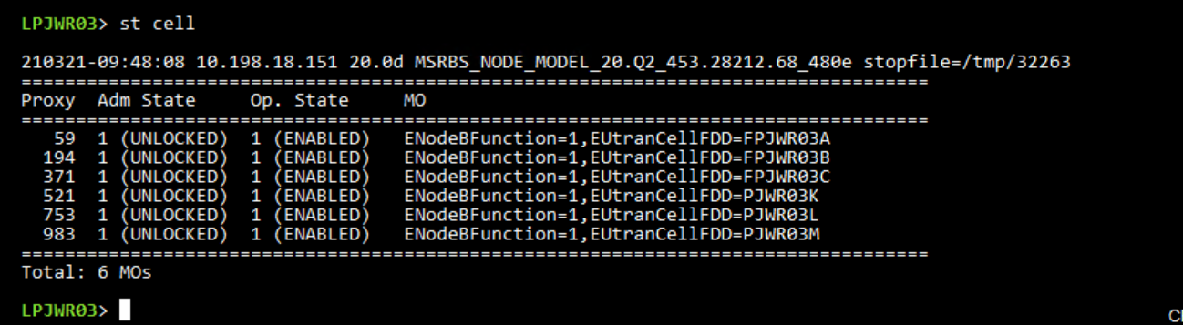

* To check Current Alarms

Alt

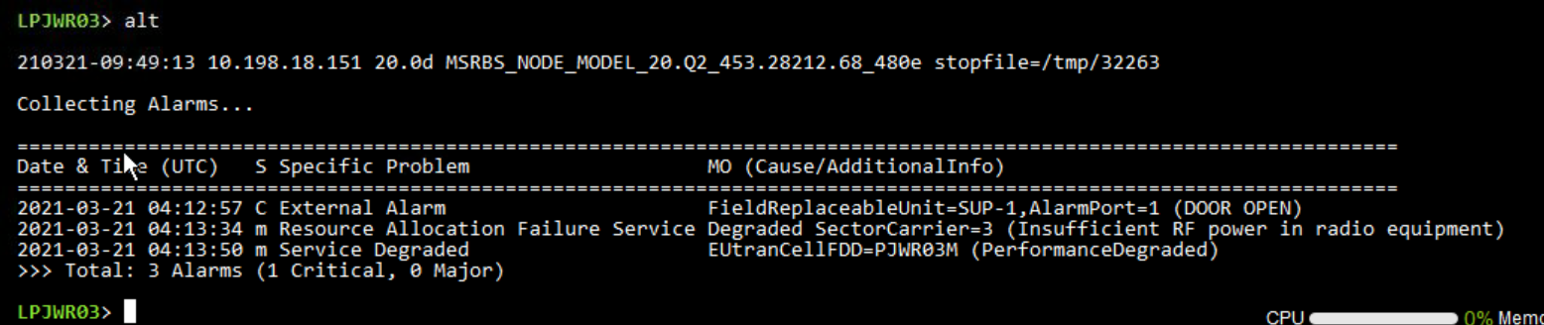

* To check RRU Status

st rru

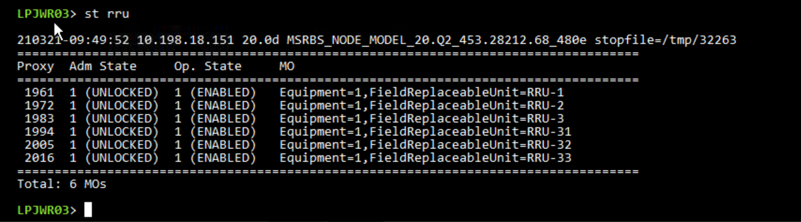

* To check MME status

St mme

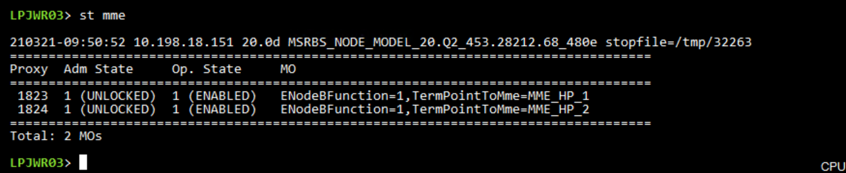

* To check RRU product detail.

Hget rru pro

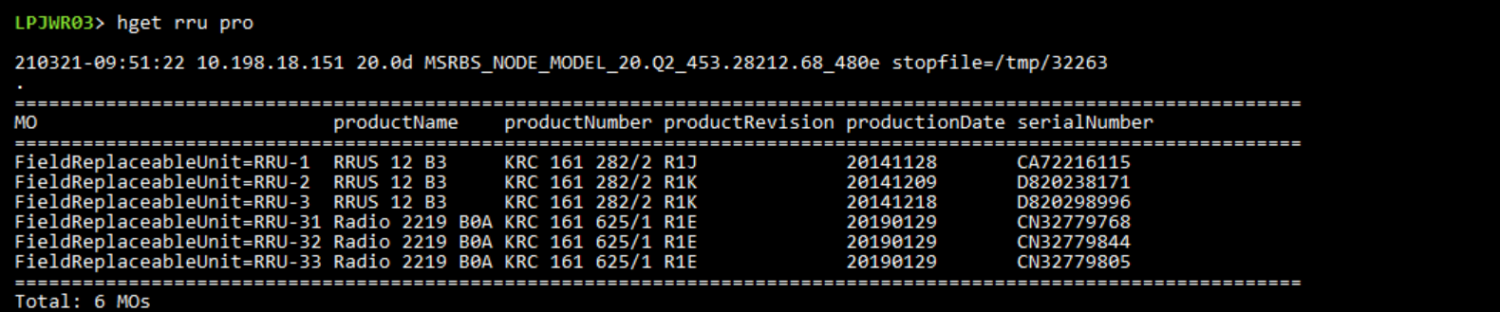

* To check current software version

Cvcu

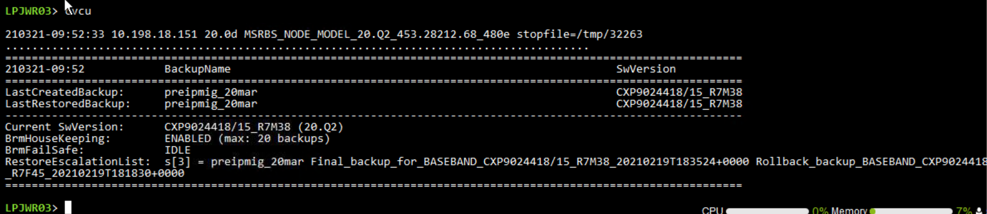

* To check vswr and serial no of used bbu and rru

Cabx

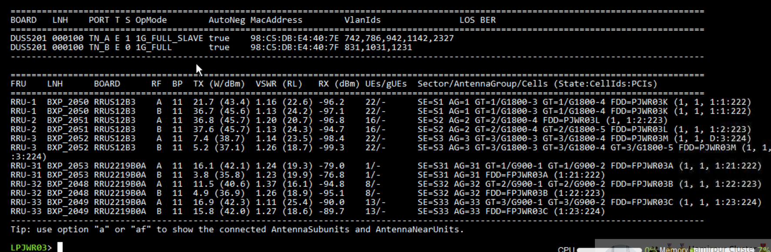

* To check abis

St abis

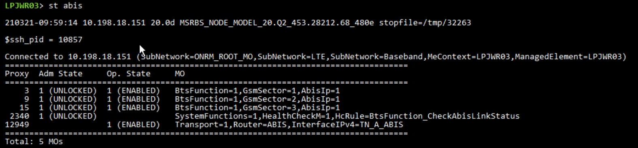

* To check linkrate

Get . linkr

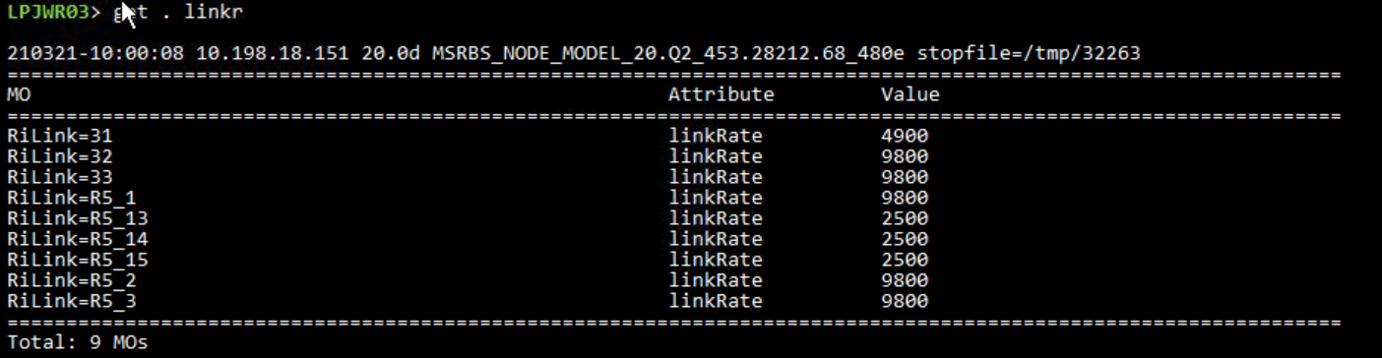

Get rilink

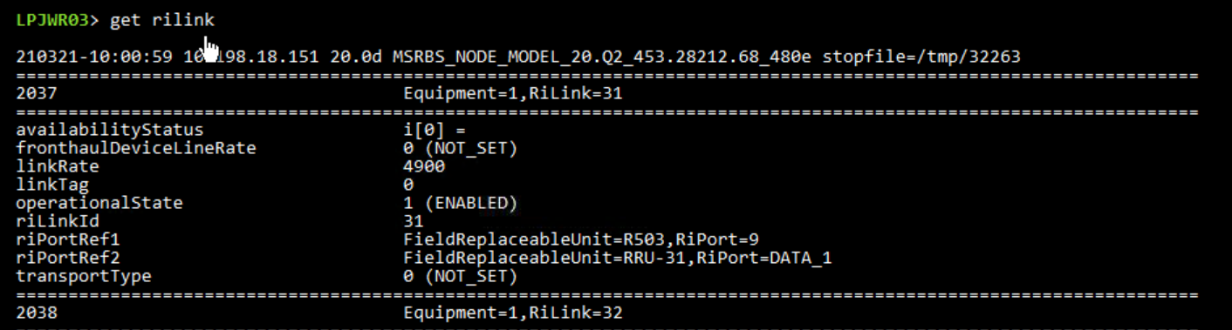

* To check gps status

Gpsstatus

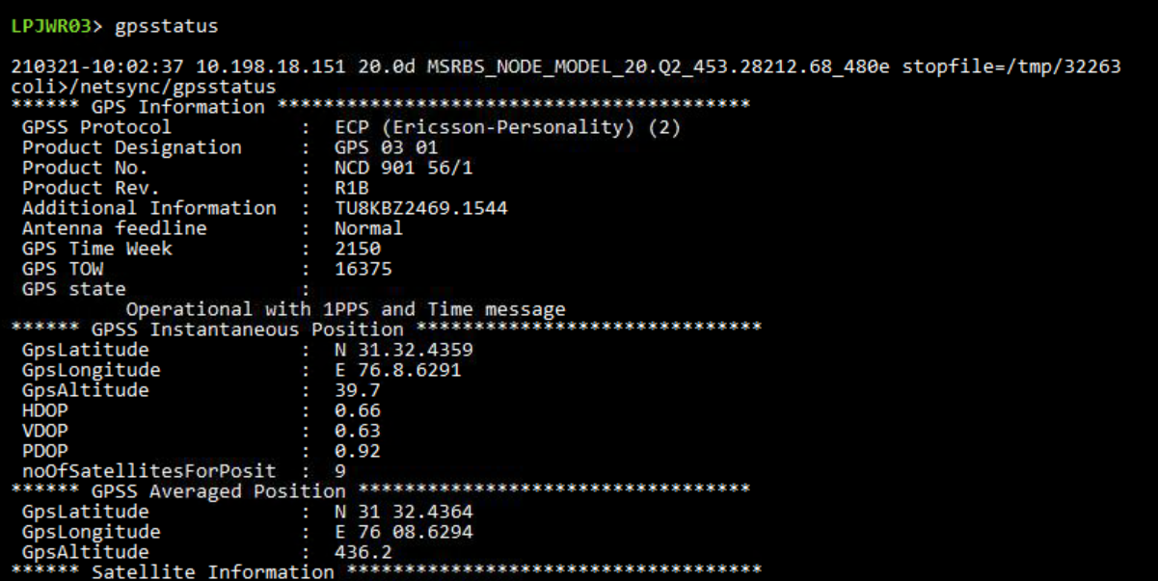

Get gnssinfo

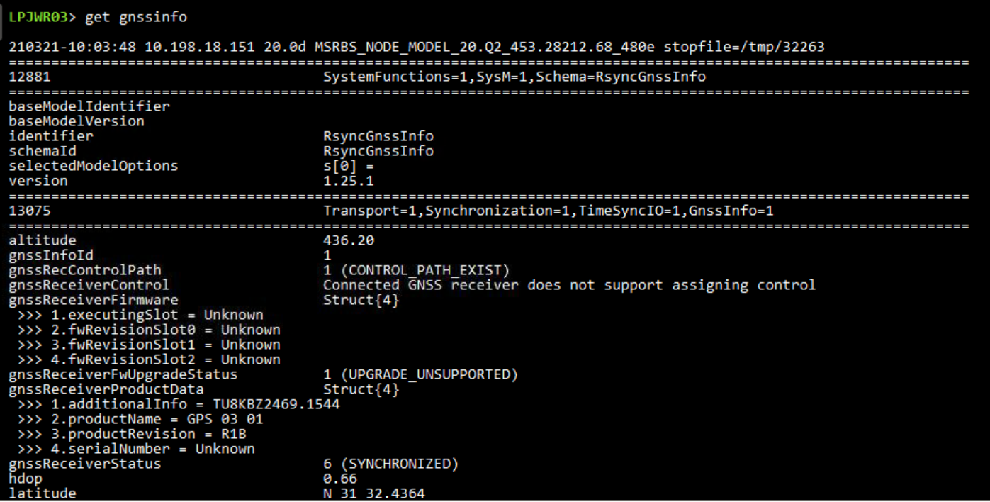

* To check time and phase

Get . timeandp

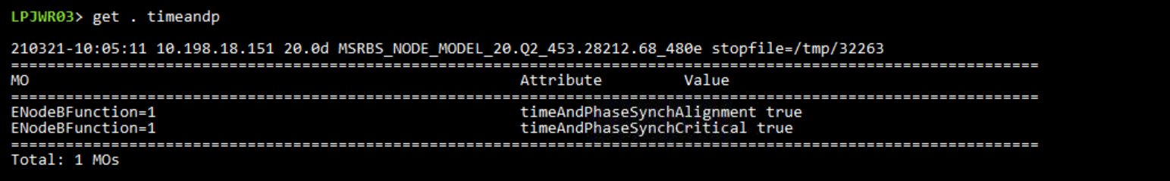

* To ping service gateway

mcc Transport=1,Router=LTEUP ping 10.206.80.47 -c 20 -s 1472

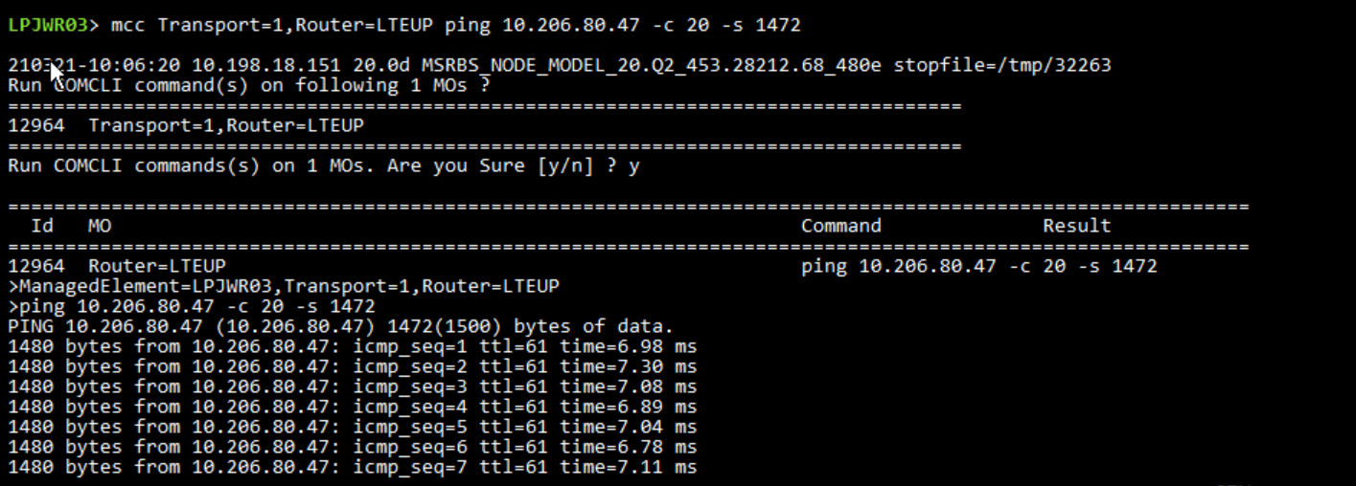

* To ping mme

mcc Transport=1,Router=LTECP ping 10.155.90.121 -c 20 -s 1472

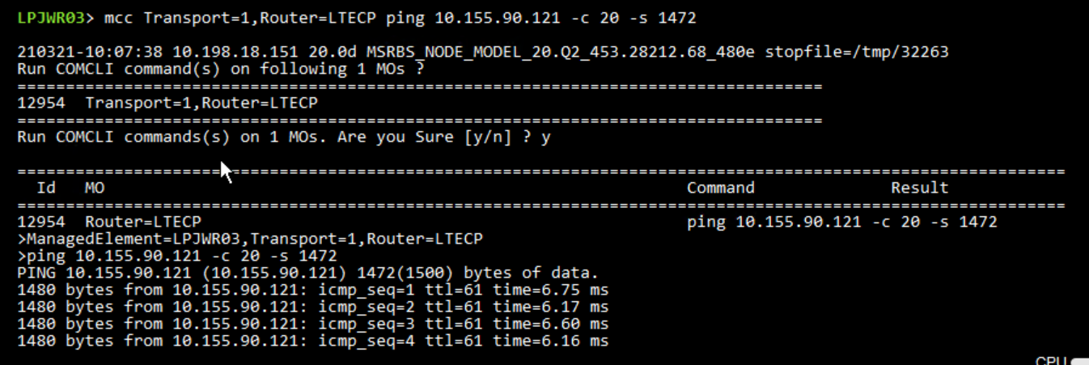

* To check software on enodeb

Lpr upgrade

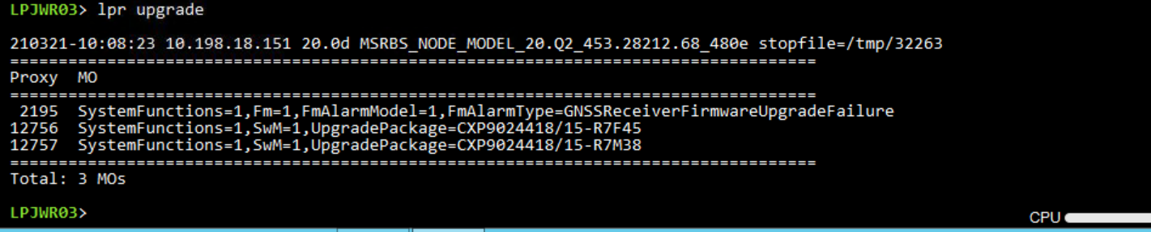

* To check port status

St port

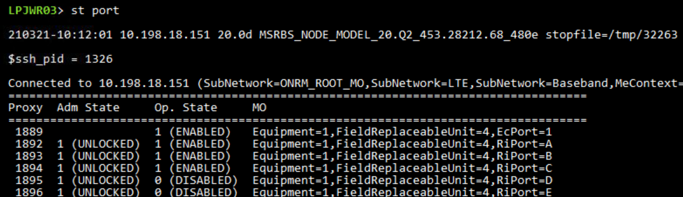

* To check sectorcarrier

St sector

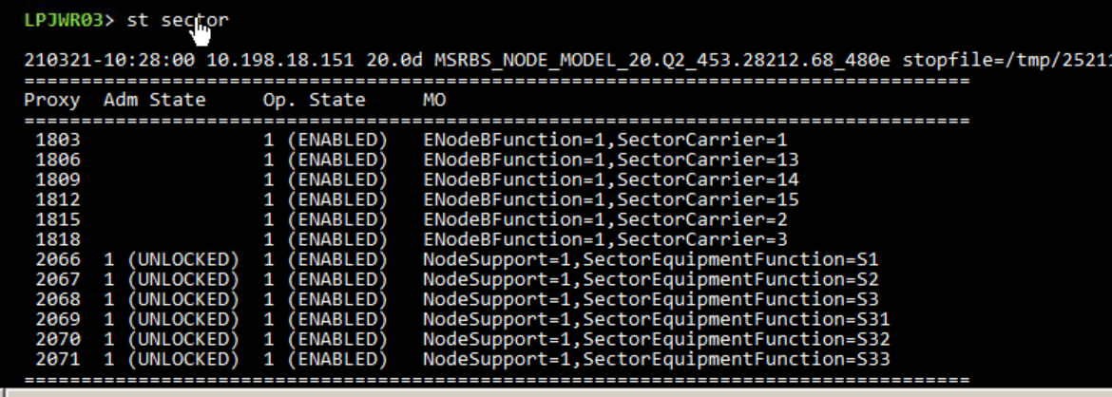

* To check cell on sector carrier

Get (Proxi)

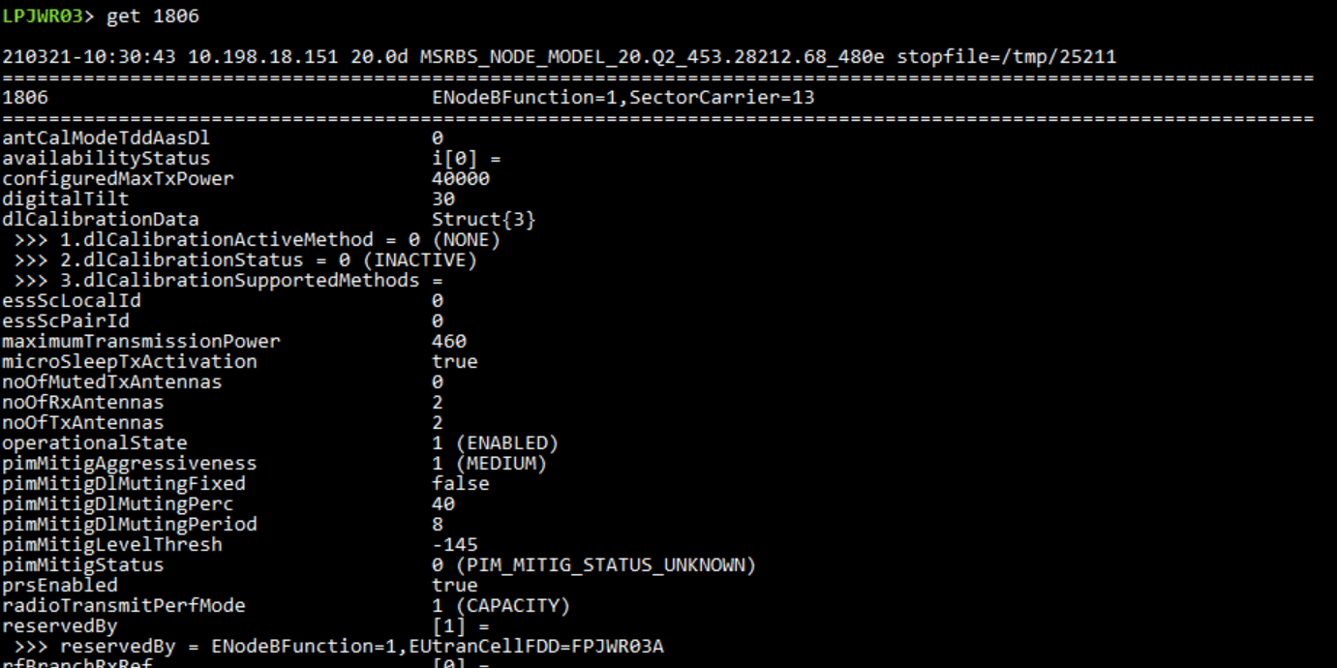

* To check ret status

St ret

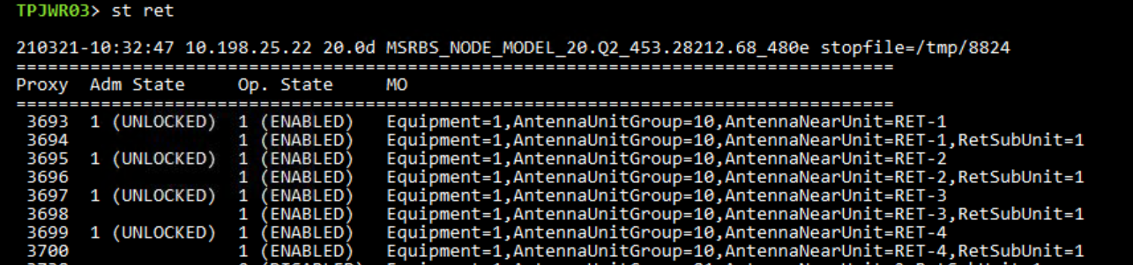

* To check cell power

Get . maxtxp

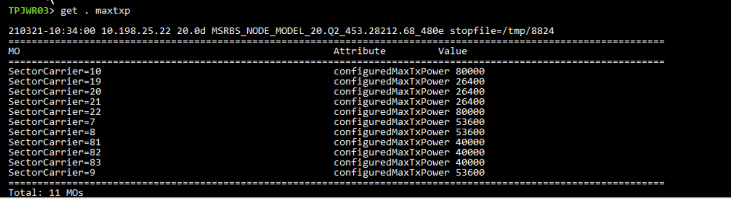

* To check remote electrical tilt

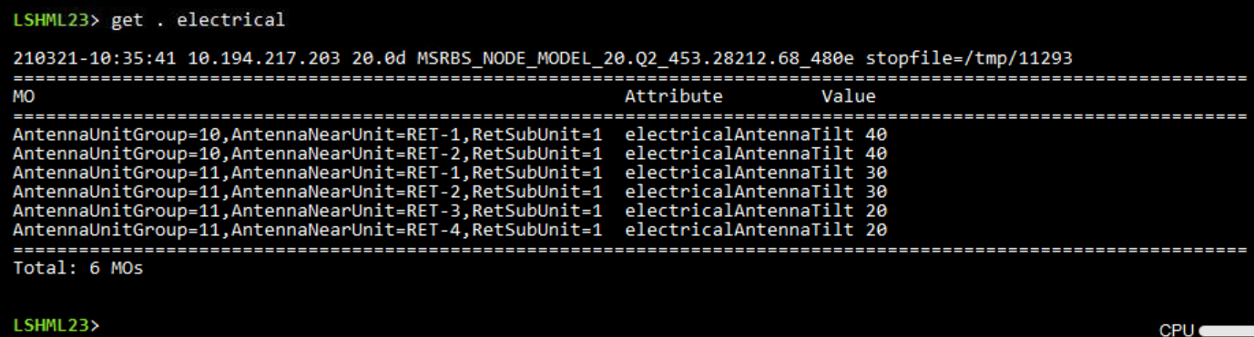

* To check node up time

Uptime

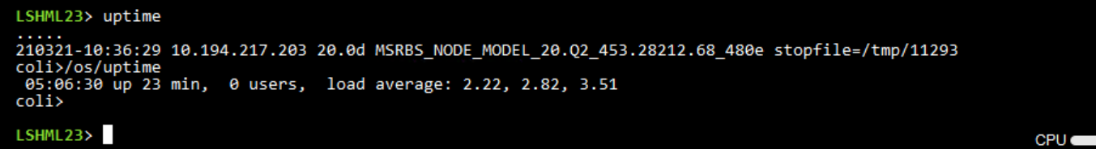

* To check radioclock

Get . radioclock

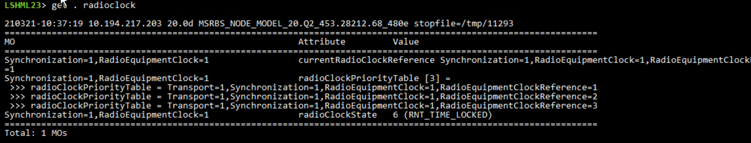

* **To check oam ip**

**Get tn_a_oam**

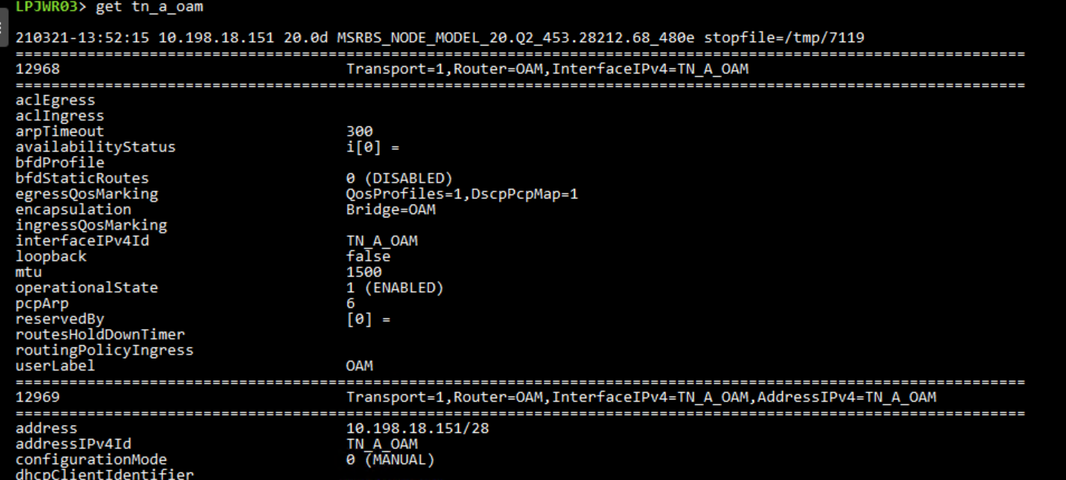

* **To check cp and up ip**

**Get tn_a_cp**

**Get tn_a_up**

**To check ethernet**

**Get . ethernet**

g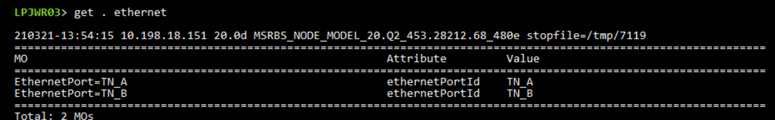

* **To check alarm log**

**lga**

